/*Ashok Mo.Proj R1SP4 Story6 Lab 7.31.19*/

Homework:

R1:SP4: Story 6 – Design and Load the data in a Dimensional Model. Create at least one Type 2 SCD. 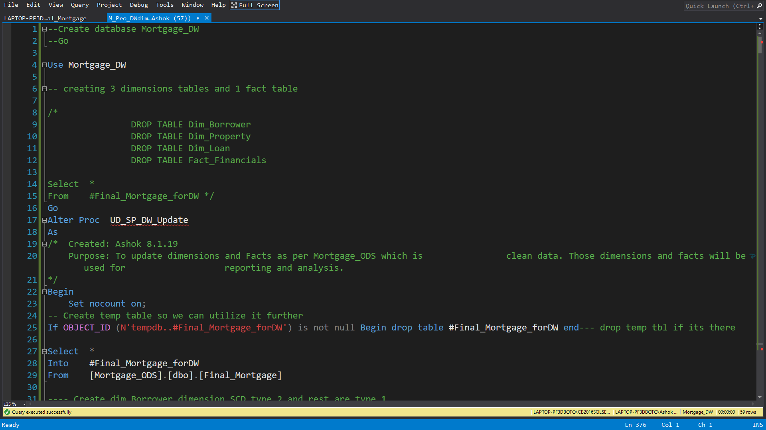

Here we are going to create stored procedure inside that store procedure we will mention the property and the Tories alone then fact table as a financials. now we are going to get the temporary table as shown in the image with checking if it is not available

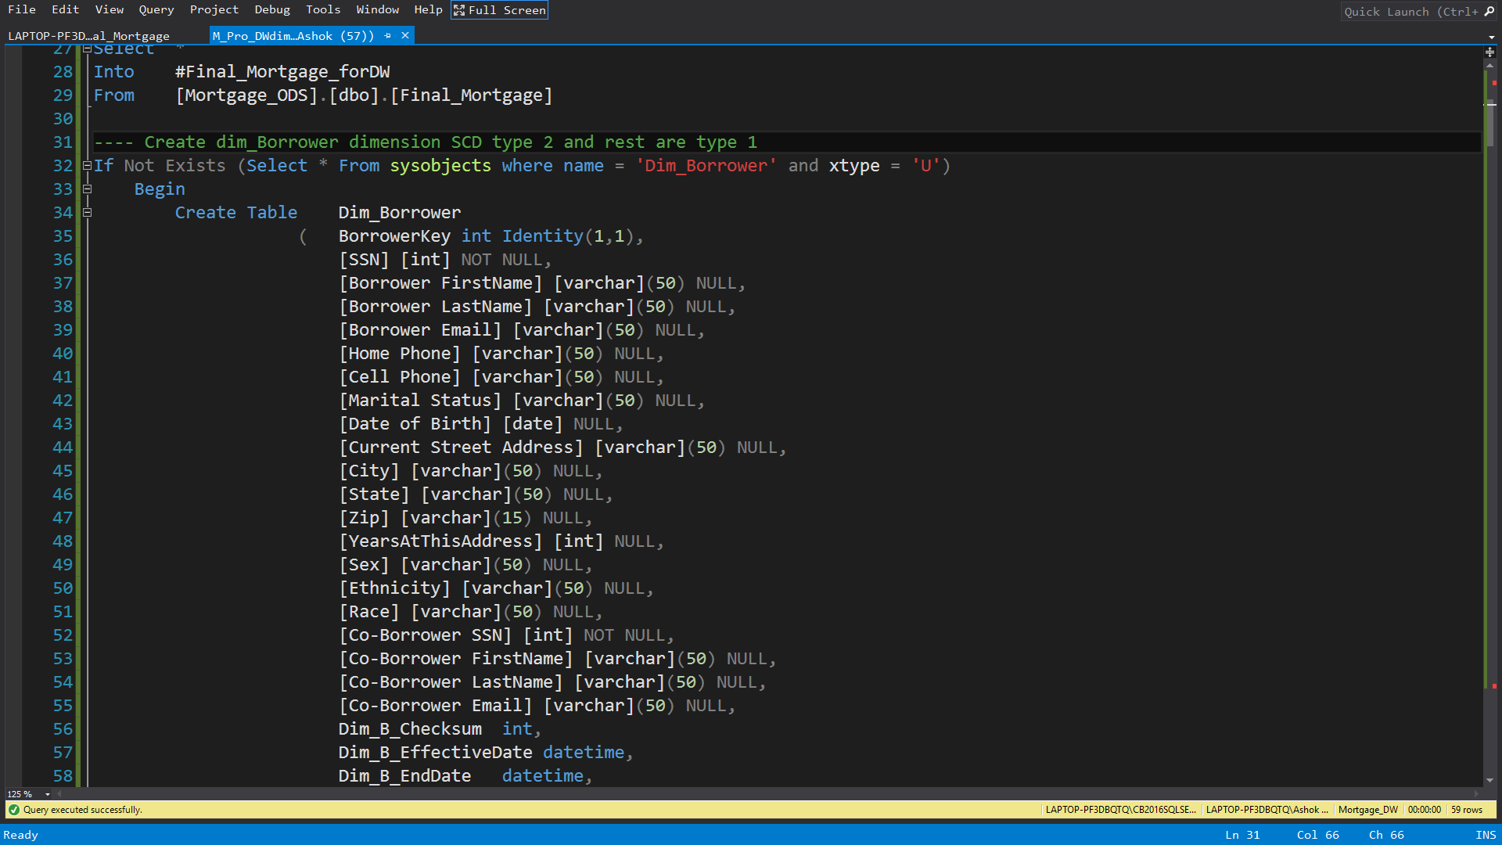

Now we are going to create dimension which is a type 2 SCD

and here we are going to create a table with different columns for dimension borrower

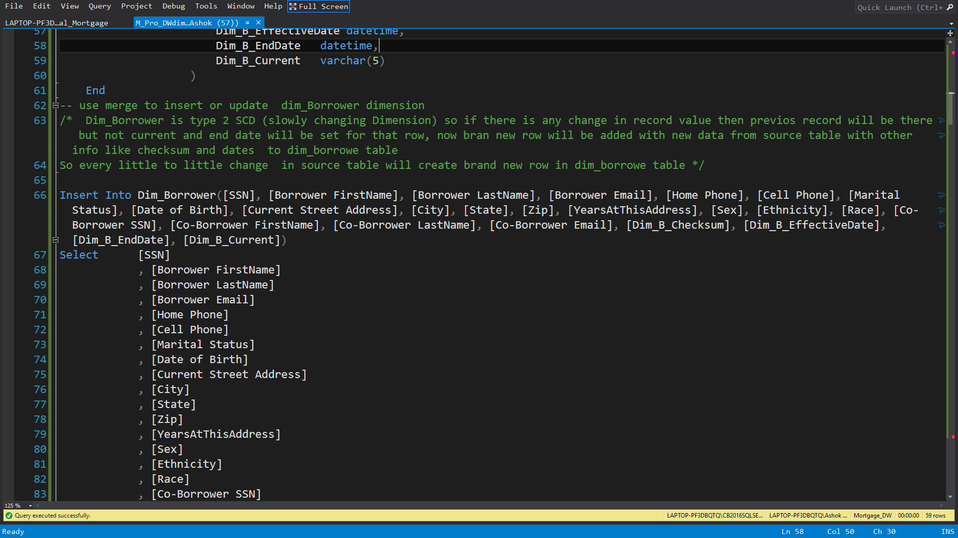

Now we are going to use Merge in SQL Server so we create insert into statement and selecting all the column of our dimension Dim_Borrower

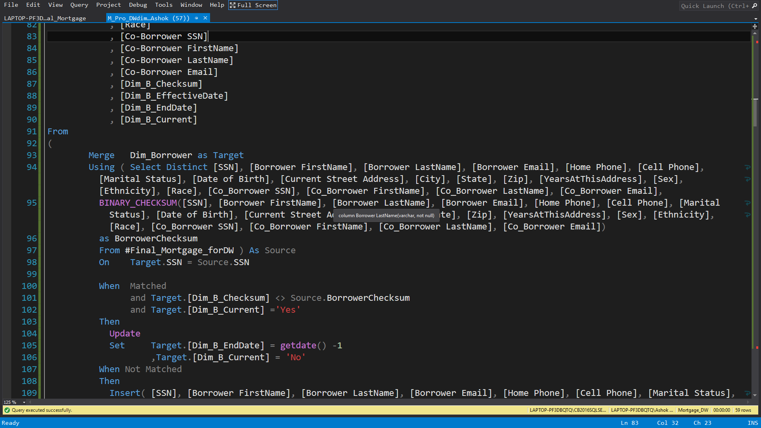

Using Merge statement, we select all the Columns of temporary table based on SSN match. If Match and checksum is not same then update dimension and not match, then insert new row.

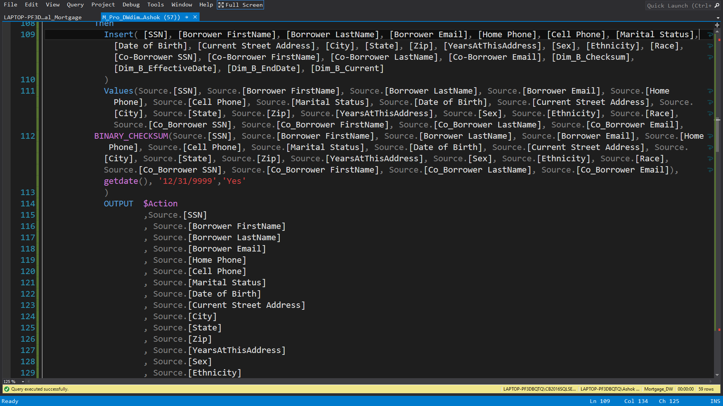

Now if there is no match then we will insert a new row in a what I mention as shown in image. We use output to update the rows of dimension.

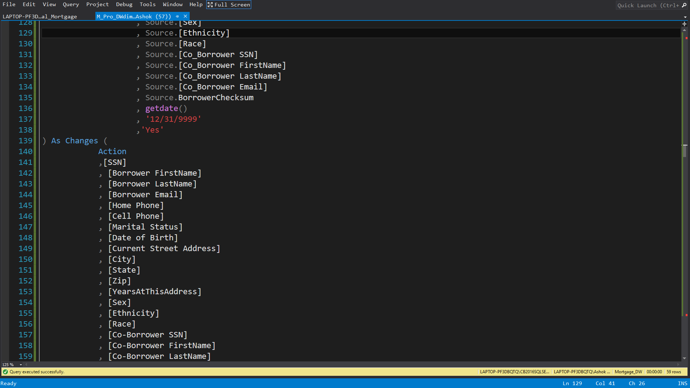

We use Action to capture updates in source table so we can load it into dimension Dim_Borrower

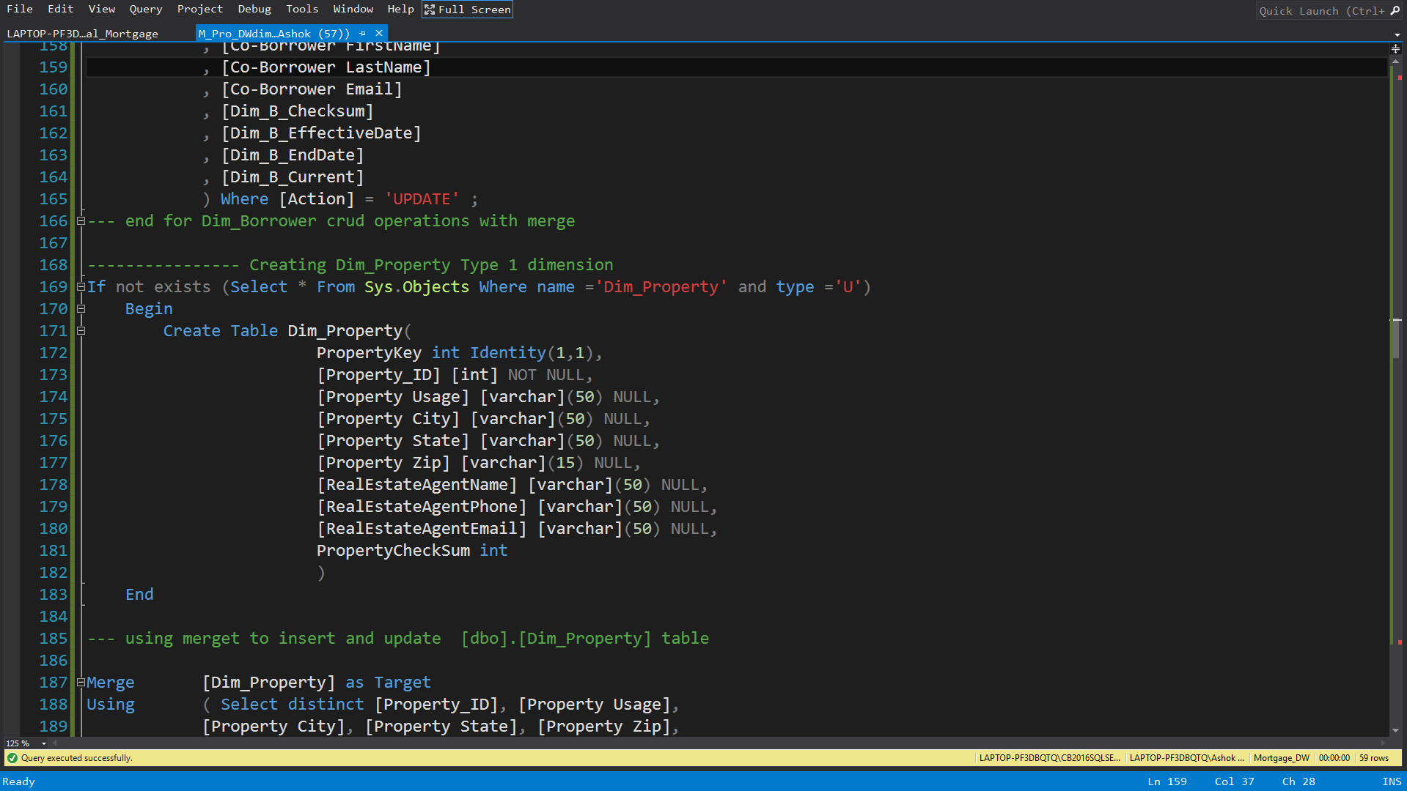

Now we create Dimension property so here we use if not exists and create the table

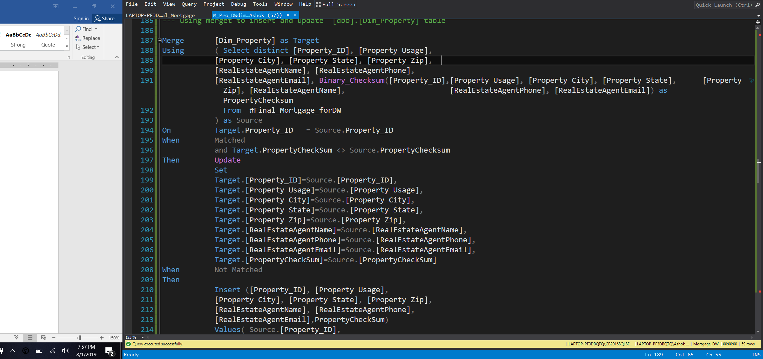

We use Merge statement to update dim_property  Dimension table with comparing to our temporary table. if it's a records match and checksum is not same then we update it otherwise if record not match then we create new row

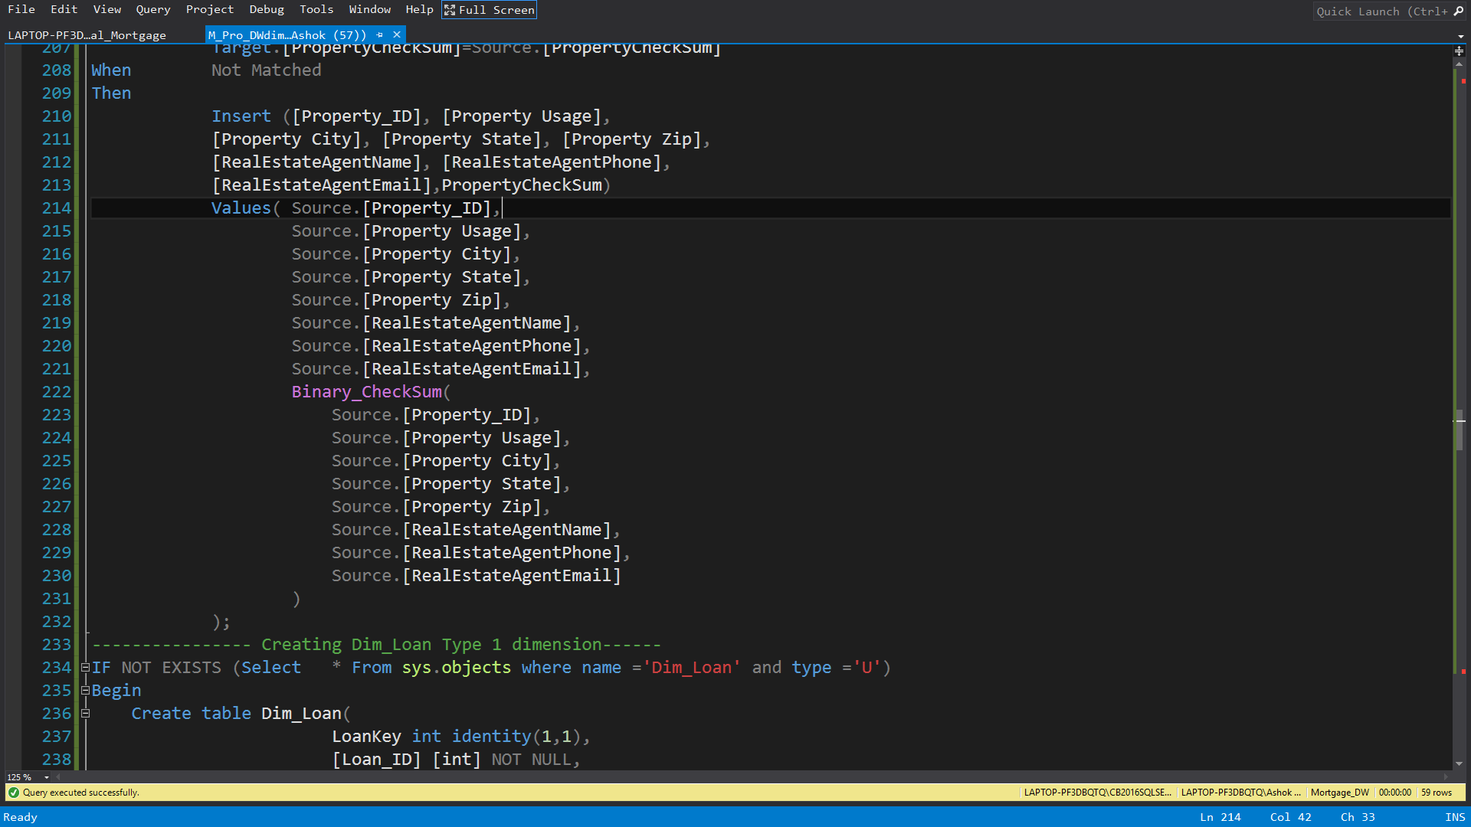

Here we are insert a new record did the help of binary checksum inside property dimension

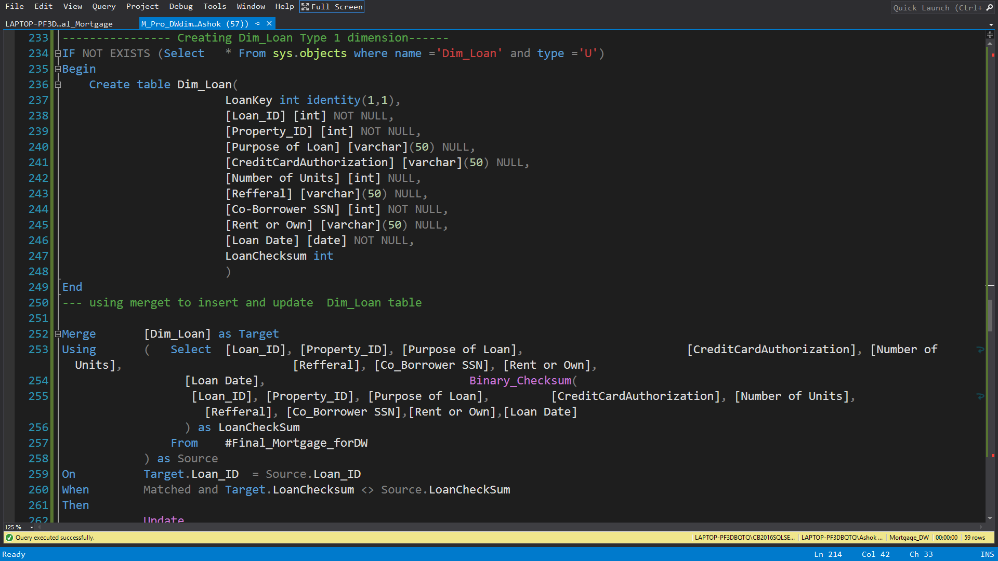

Now we use if not exists go create another dimension Loan with its related columns

Also we use Merge statement with using and select, we check the data in Dimension loan and Compare it to the temp table to update the record or insert new row

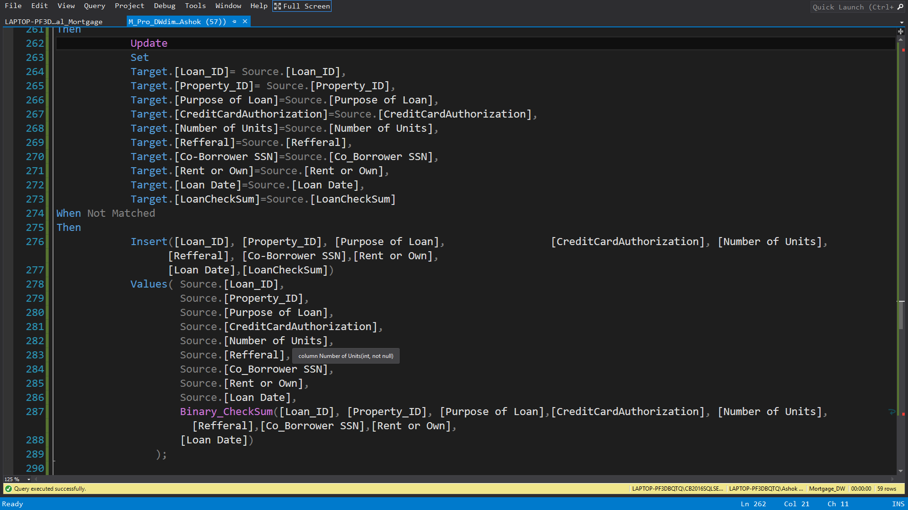

Here we use merge and if the data row is not match then we insert new record with the help of binary checksum inside loan dimension

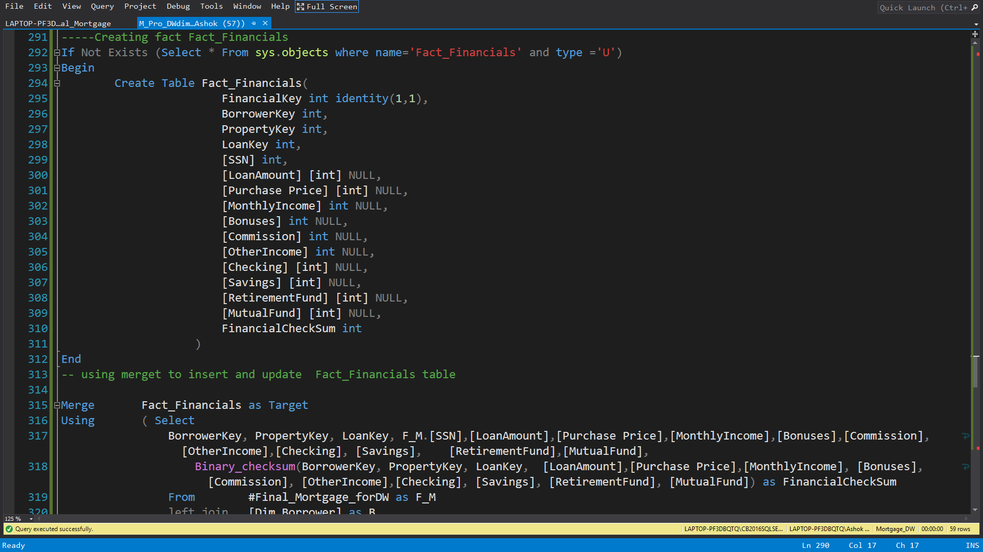

Now we create fact financials with the help of if not exists function with specific columns from different dimensions and other miserable items of our business

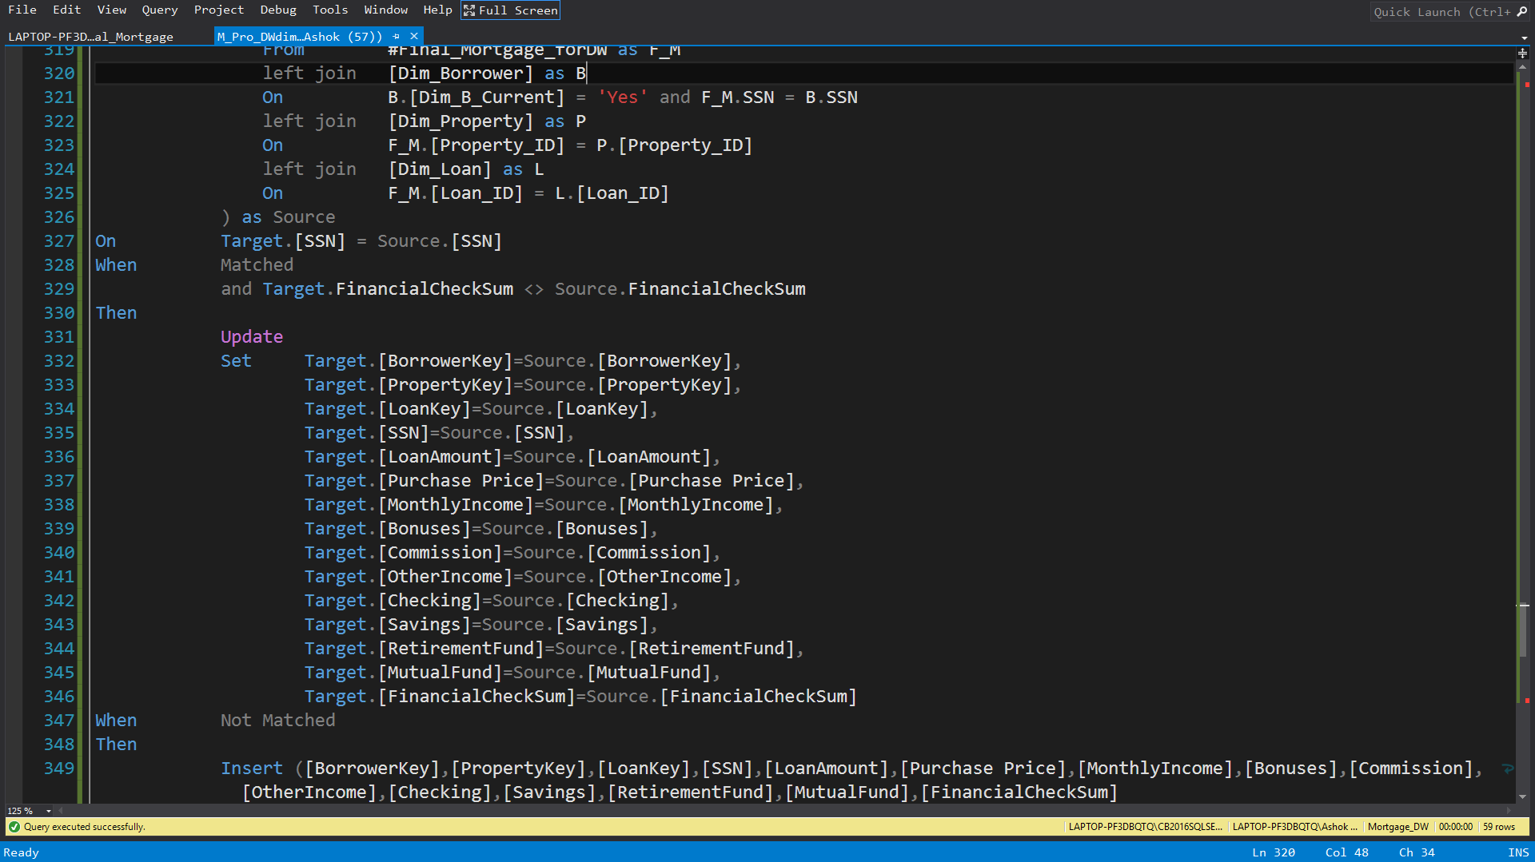

We use Merge to update our fact table or insert a new Row Record with the help of binary checksum and we will end our stored procedure which is user Defined

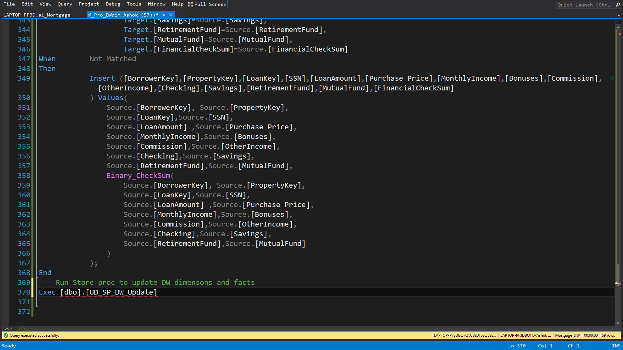

Also we can execute stored procedure in SQL Server agent or inside ssis SQL task in packages

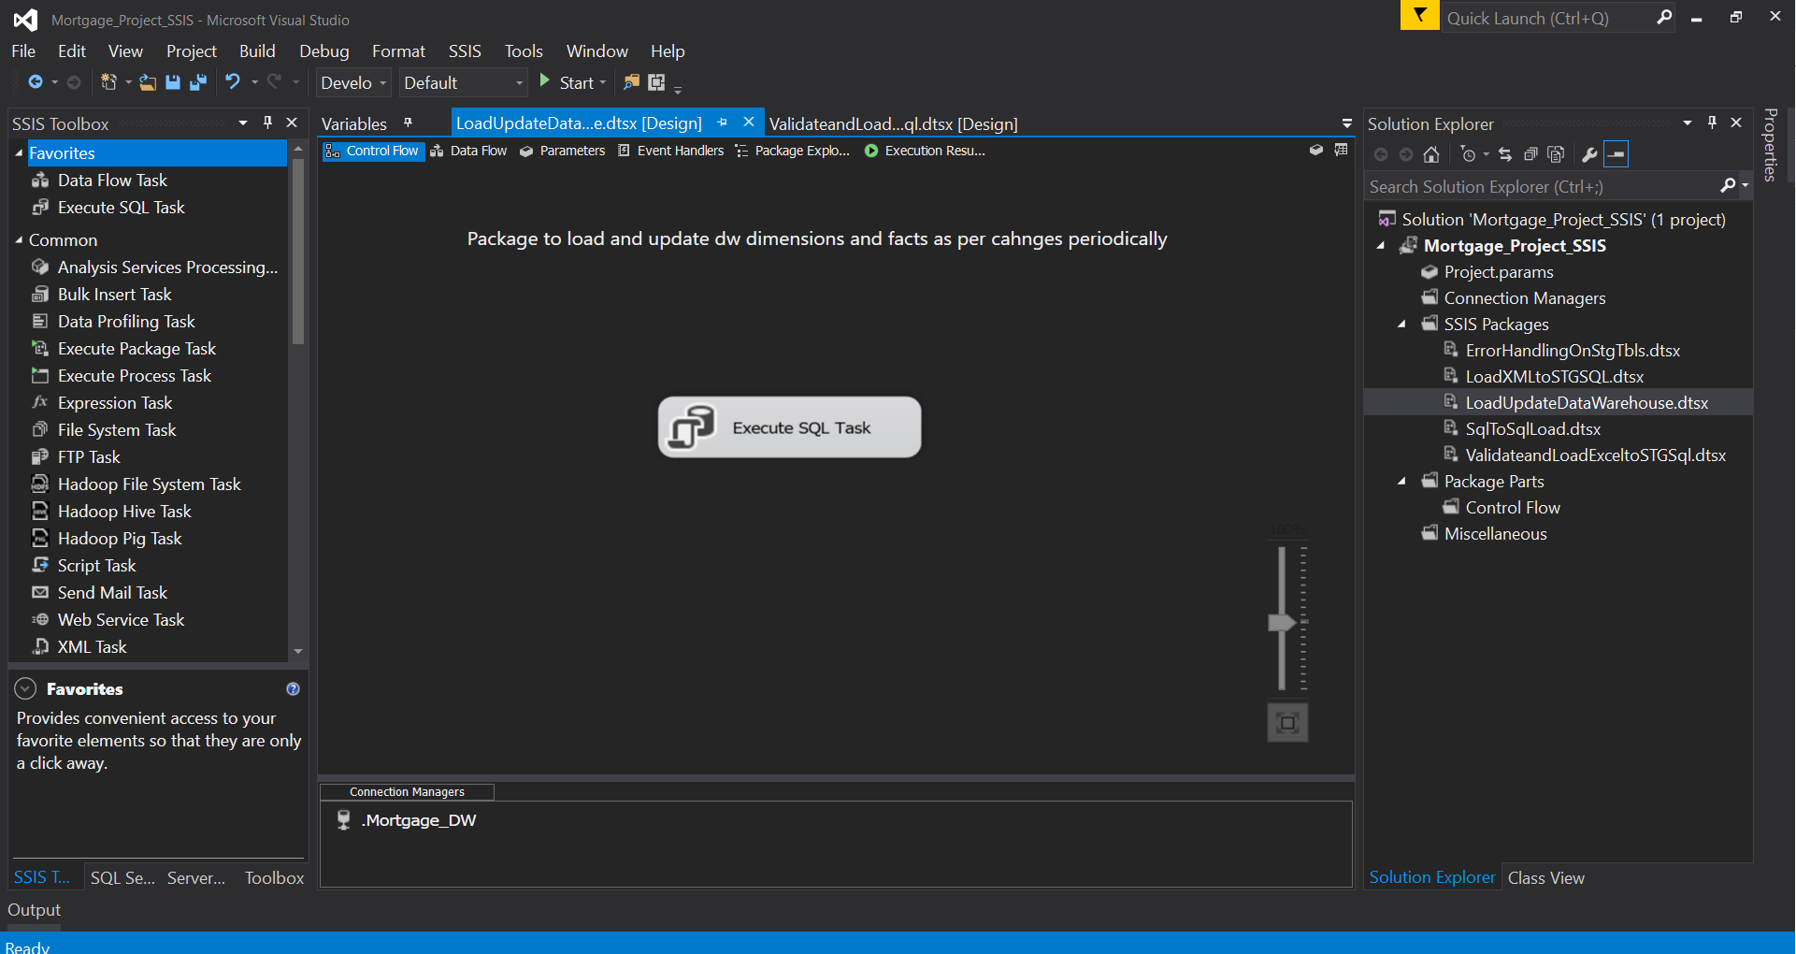

This image is from ssis package which uses execute SQL task

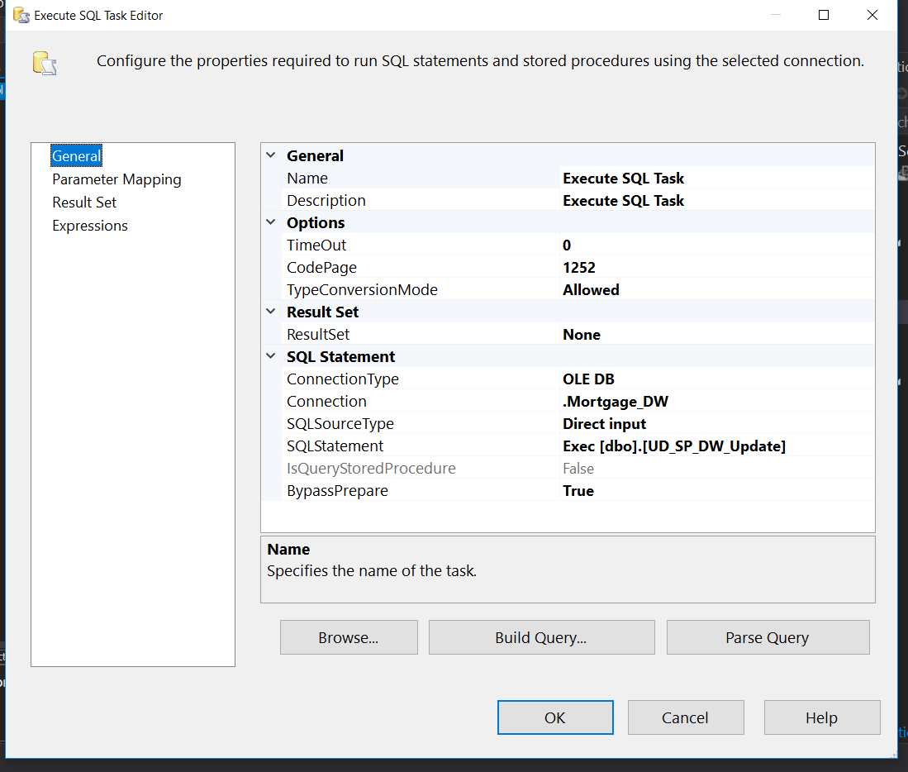

Here we can see execute SQL task editor where we select our connection to database and a statement to run stored procedure

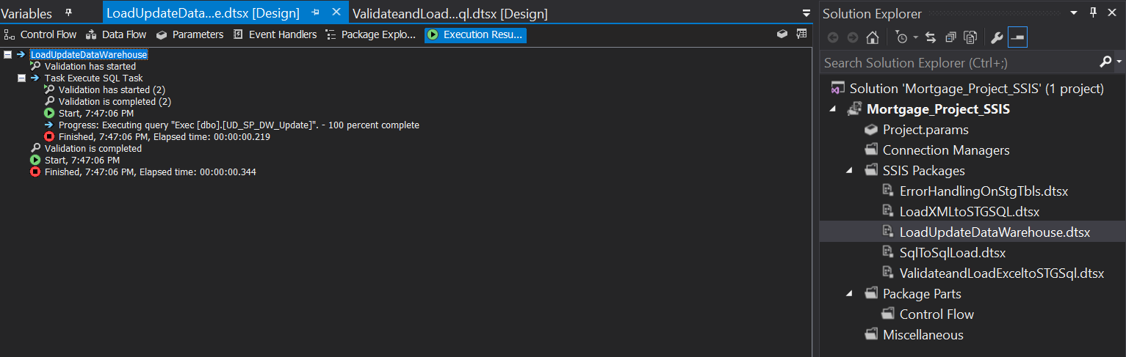

Above image Souls the complete execution of SQL task in ssis with 100% complete

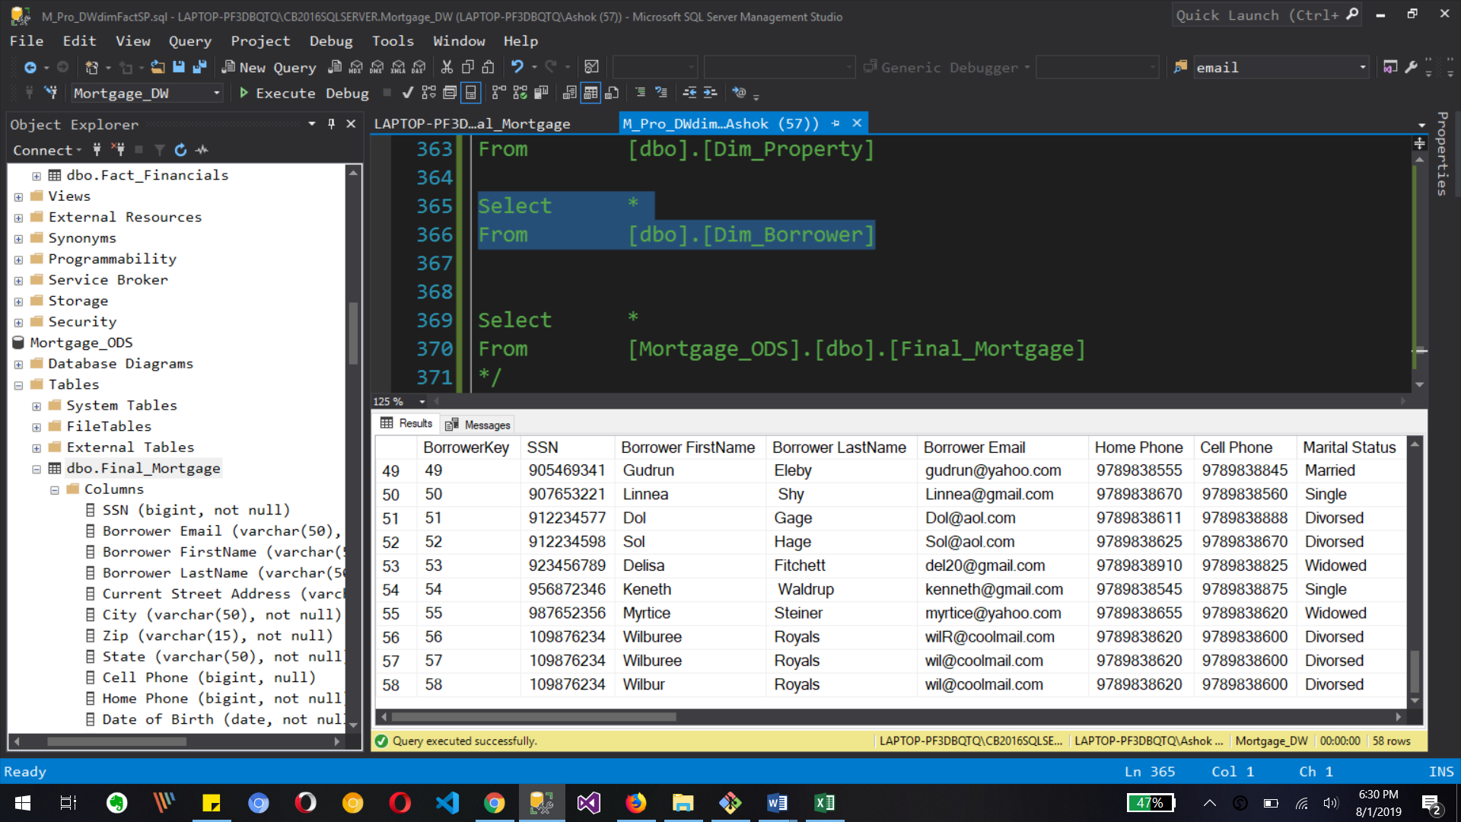

Our Dimension Borrower shows that stored procedure code creates 3 new record as 56, 57 and 58 line number because our Dimension is SCD type 2 for changes in our source table data.

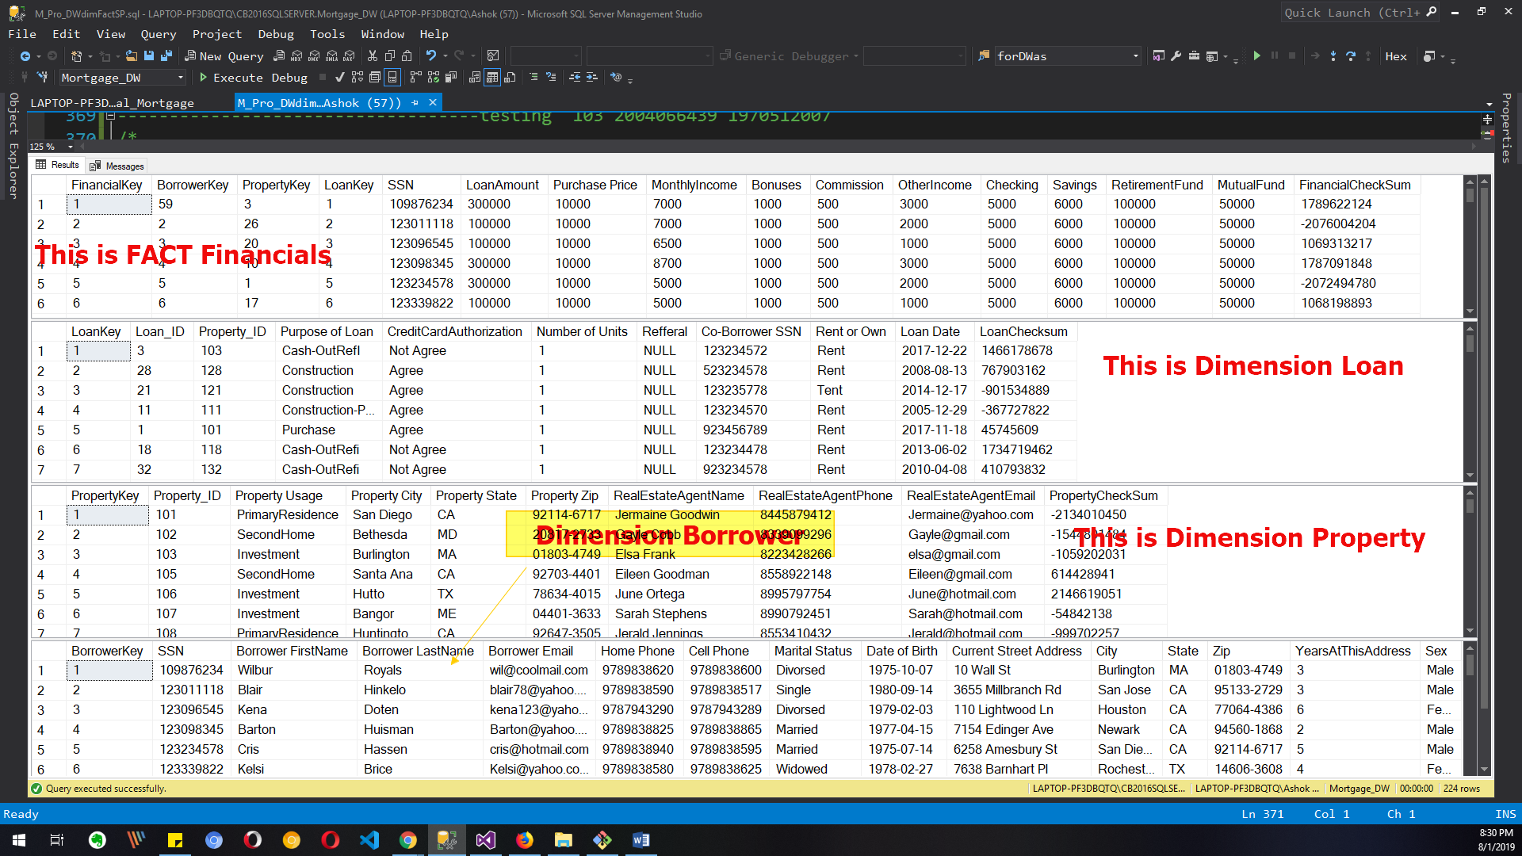

This is final output in ssms for dimensions and fact tables rows which shows all update records of data warehouse. So we can use them for reporting and analysis.

What to Submit:

1. IPBC Status Update : Mortgage Project Story 4-6

2. SQL BI Interview Questions: SSAS – What is a Slowly Changing Dimension – Explain Type 1 Type II and Type III

<https://app.colaberry.com/app/ipbc/videos?user=31221&category=54>

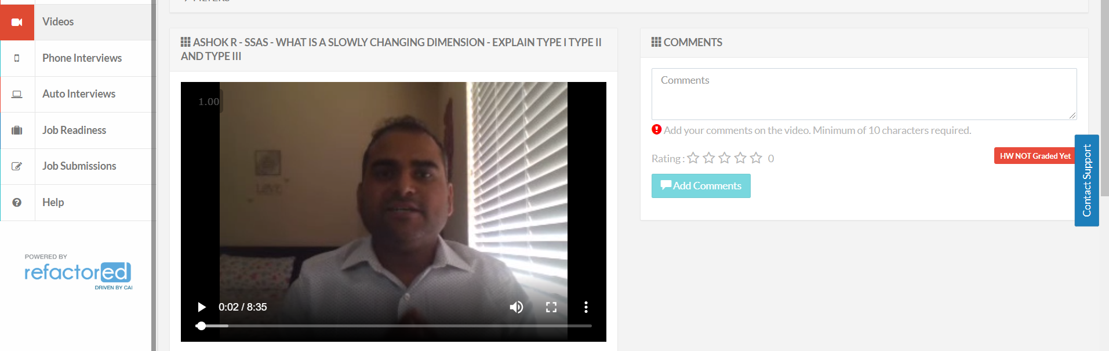

2. Watch, Comment &amp; take screenshots of your comments from 3 other videos on the same topic (per question). Comments must be 20+ characters. Leave comments based on presentation, delivery and/or technical details. Your critiques will help you be more conscious of your own videos. (3 comment screenshots per Video Question)